SQL PROJECT

Create table Sales

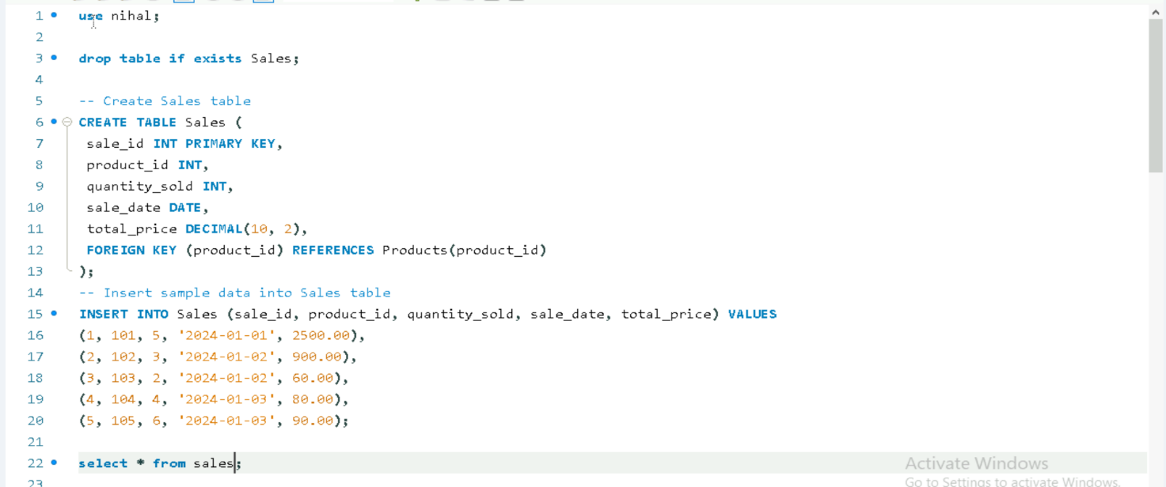

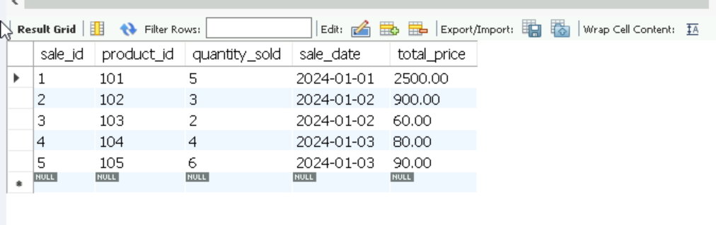

Create table Products
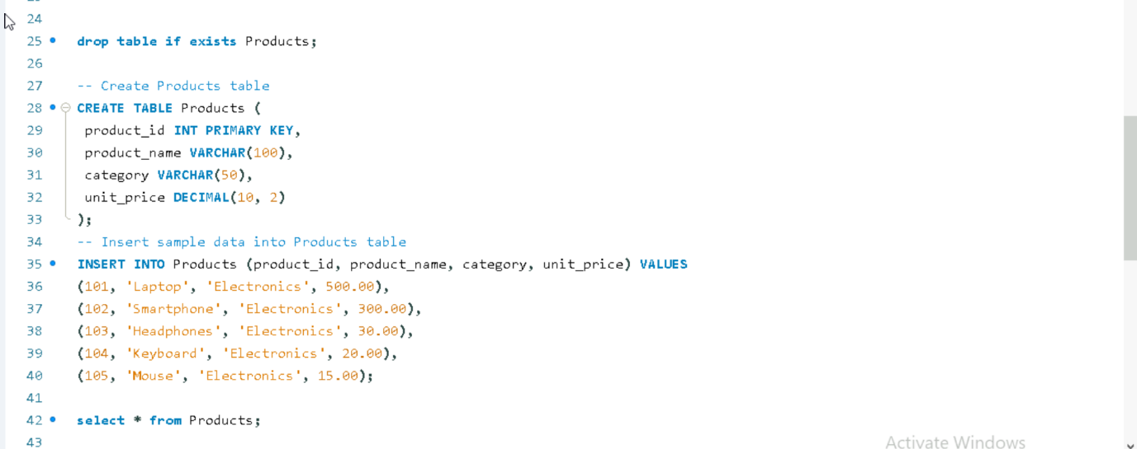

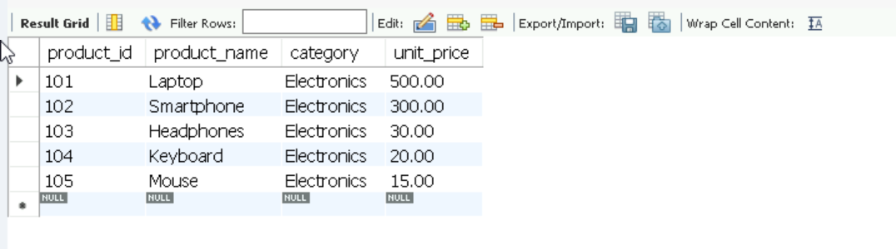

Questions

- Categorize sales as "High", "Medium", or "Low" based on total price (e.g., > $200 is High, $100 - $200 is Medium, < $100 is Low).
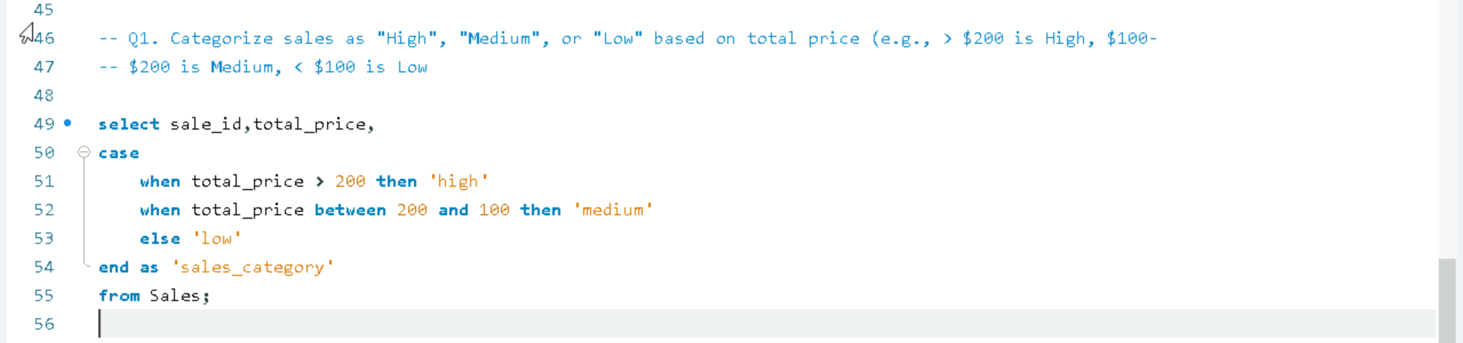
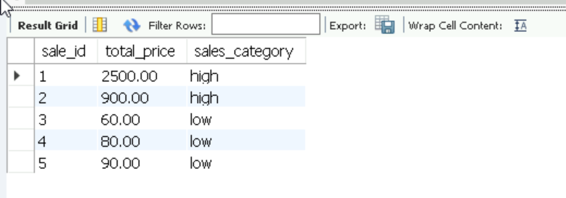

- Identify sales where the quantity sold is greater than the average quantity sold.

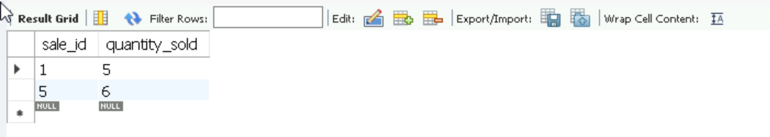

- Calculate the number of days between the current date and the sale date for each sale.

